**EXPERIMENT 2**

**AIM:** To design a static web page using CSS3 CSS Properties, CSS Styling(Background, Text Format, Controlling Fonts) , etc..

**THEORY:**

1. **What is CSS**

**Cascading Style Sheets** (**CSS**) is a style sheet language used for describing the presentation of a document written in a markup language like HTML.[[1]](https://en.wikipedia.org/wiki/Cascading_Style_Sheets#cite_note-1) CSS is a cornerstone technology of the World Wide Web, alongside HTML and JavaScript.[[2]](https://en.wikipedia.org/wiki/Cascading_Style_Sheets#cite_note-2)

CSS is designed to enable the separation of presentation and content, including layout, colors, and fonts.This separation can improve content accessibility, provide more flexibility and control in the specification of presentation characteristics, enable multiple web pages to share formatting by specifying the relevant CSS in a separate .css file, and reduce complexity and repetition in the structural content.

## Why Use CSS?

## CSS is used to define styles for your web pages, including the design, layout and variations in display for different devices and screen sizes.

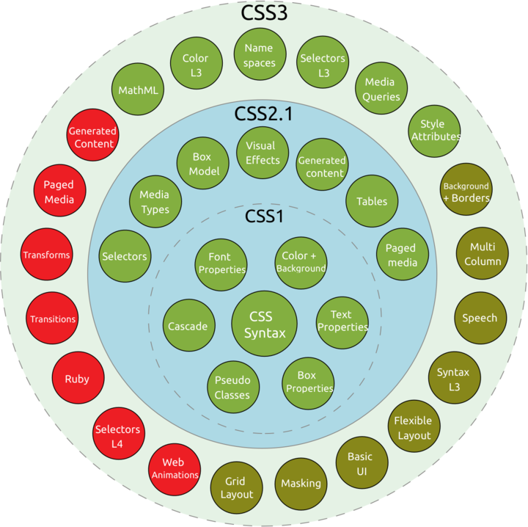

**SCREENSHOTS:**

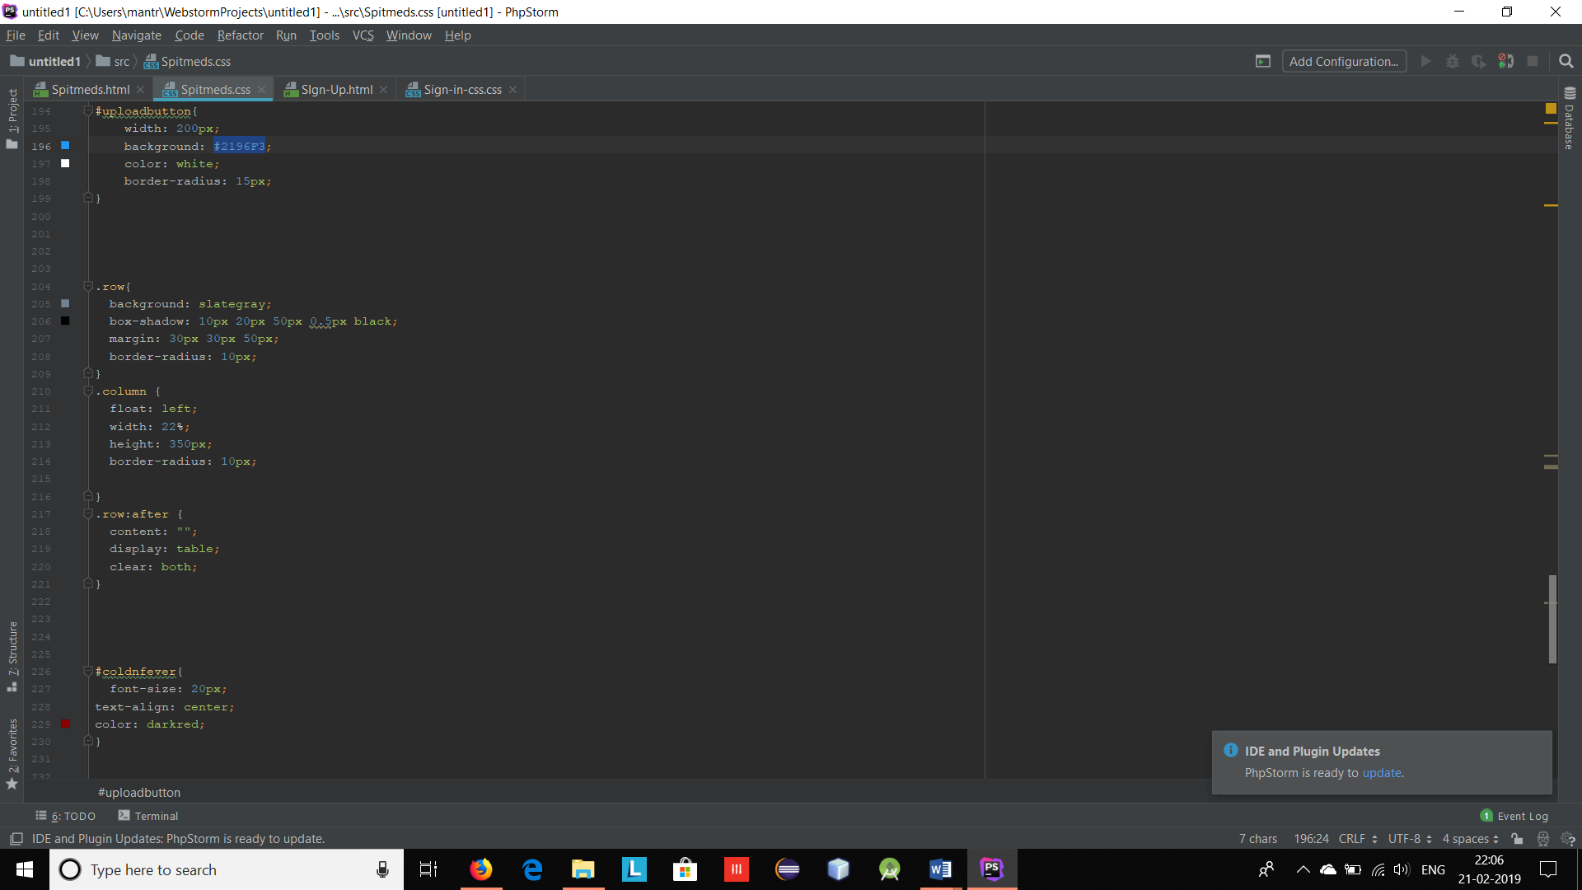

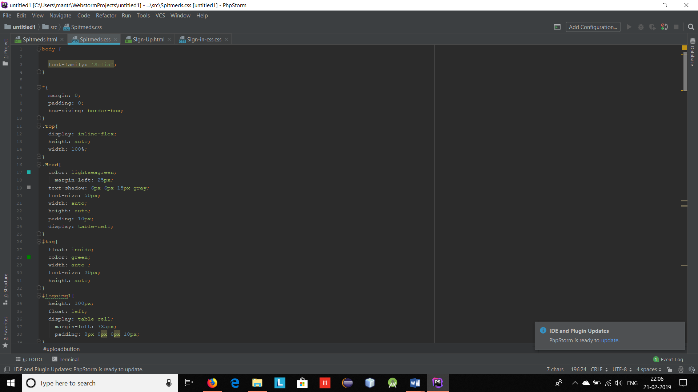

**CONCLUSION:** Got to know about CSS3 and were able to successfully implement a static webpage.